Project Design Phase
Problem – Solution Fit Template
Date | 14 October 2026
Team ID
Project Name | Automated Network Request Management System
Maximum Marks | 2 Marks

Problem – Solution Fit Template:
The Problem-Solution Fit simply means that you have found a problem with your customer and that the solution you have realized for it actually solves the customer’s problem. It helps entrepreneurs, marketers and corporate innovators identify behavioral patterns and recognize what would work and why.
Purpose:
• Solve complex problems in a way that fits the state of your customers.
• Succeed faster and increase your solution adoption by tapping into existing mediums and channels of behavior.
• Sharpen your communication and marketing strategy with the right triggers and messaging.
Template Canvas:
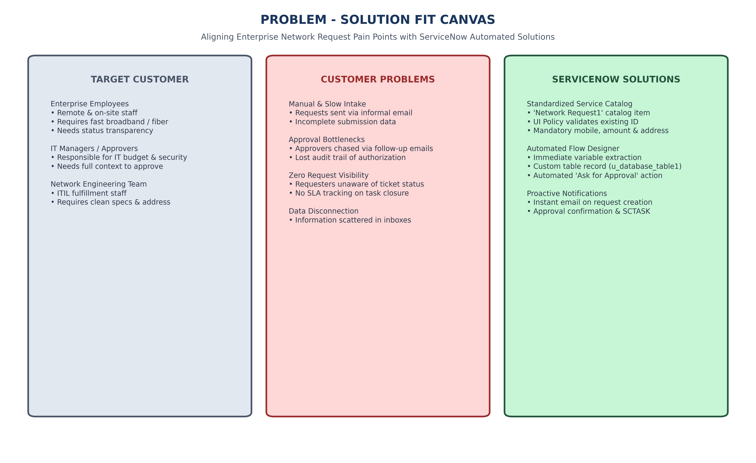
Figure 3.1: Problem - Solution Fit Canvas for Automated Network Request System

